South Bay Cities Council of Governments
Homeless Services Task Force
Wednesday, October 2nd from 3:00 pm – 5:00 pm

Meeting Link

Meeting Notes (submitted by Addy Ajijolaiya)
These meeting notes are an overview of the meeting content.
We suggest watching the video and the supporting document links for more comprehensive information.

Welcome and Introductions (55 Participants)

Elected officials / Representatives in attendance:
Sarah Rascon (Director of County and Regional Affairs, Mayor of Los Angeles Karen Bass)
Bill Uphoff (Mayor - Lomita)
Shirley Cuevas (Councilmember – Lawndale)
Paige Kaluderovic (Councilmember – Redondo Beach)
Raymond Jackson (Councilmember – Hermosa Beach)
Asam Sheikh (Councilmember – Torrance)
Janet Turner (Deputy District Director – Outreach, Office of Congressman Ted W. Lieu)
Charlene Faye Cubangbang (Intern, Office of Congressman Ted W. Lieu)
Chris Pimentel (Mayor Pro Tem - El Segundo)
Moises Aglipay (Assembly Field Representative – Office of Assemblymember Mike Gipson),

Others in attendance:
Ramon Rendon (Harbor Interfaith, Program Director)
Rita Crabtree-Kampe (Homeless Outreach – MBSAFE)
Lila Omura (Redondo, Housing Navigator)
Angela Crespi (Deputy City Manager – Hermosa Beach)
Raeann Munoz (Public Safety Officer – City of Carson)
Dulce Medina (Homeless Services Coordinator – City of Hawthorne),
Laurie Ramey (MHALA)
Shannon Murray (Director, Homeless and Housing Services – WLCAC),
Paul Stansbury (President – NAMI South Bay),
Richard Wise (Catholic Charities/St. Margaret’s CM)
Jonathan Said (Homeless Services Manager, Catholic Charities / St. Margaret’s Center),
Cliff Gardner (Faith-Based Regional Coordinator SPA 8 – Harbor Interfaith Services),
Grace Weltman (Chair – SBCEH)
Marlen Pomposo
Erik Vargas (Community Relations Coordinator, SPA 8 – LAHSA),
Janet Kelly (Sanctuary of Hope, Executive Director)
Yvonne Golub (Case Manager Blue Shield),
Joe Vargas (Public Safety Engagement Officer – City of Carson),
Luke Muir (Lieutenant Patrol Division – City of El Segundo Police Department),
Lori Jones (Grants Coordinator – City of Inglewood)
Laurie Jacobs (Homelessness and Mental Health Solutions Advocate),
Marolly Vasquez (Outreach – Carson)
Lee Phillips MD
Marlen Pomposo
Fariba Moghadam (Housing & Homeless Coordinator – Carson)
Andre Thomas (Regional Director – Sanctuary of Hope)
Dianna Espinoza – (Homeless Coordinator – Gardena)
Carielle Escalante (COC and CES Representative)
Kara Noble (Los Angeles Department of Public Health)
Andrea Murray Kitchen (A Sense of Home)
Brodie Butler (A Sense of Home)
Roberto Chavez (Program Manager – Inglewood Housing Authority)
Micky Daniel (Programs – Inglewood)
George Gabriel (Assistant to City Manager – Manhattan Beach)
Barbara Voss (Deputy City Manager – El Segundo)
Zulma Gent (Management Associate, Torrance)
Ana Abril (Supervisor -PATH)
Kiana Ephriam (PATH)
Gloria Johnson
Robin Wilson (Public Works Program Administrator, Carson)
Meghan Langfield (Executive Director – Harbor Connects)
Kailee Caruso (Municipal Relations – CEO Homeless Initiative),
Marco Santana (Municipal Relations – CEO Homeless Initiative),
Catherine Hetzer (Project Assistant – SBCCOG),
Miranda Werts (Project Coordinator – SBCCOG),
Ronson Chu (Senior Project Manager – SBCCOG)

Meeting Summary:
SPA 8 Updates - Carielle
- Minimal COC updates, canceled August meeting and couldn’t attend September
  - There were discussions about dollars for the DV unit, gave more detail about their work so they could continue with the ask for those specific funds
- CES Policy Council
  - August: discussed term limits, and chair and vice chair. Now there will be 3-year term limits and will stagger them in 3 different groups.
  - . The Chair and Vice Chair approved. Michael Brassweifer?
    - Leadership will help set priorities, agenda
  - PSH Queues (still a lot of questions about the numbers, how they’re defined, etc. but a good starting point)
    - Moving forward, using PSH qualifying score, active CES program enrollment, and documents uploaded on HMIS (not using active point of contact any longer) for matching. No information was added for DMH or DHS
    - For adults: The majority of clients in queue are in street outreach (54%), IH (36%). Male, Black, Hispanic, Latine. Average time in the system is 4.5 years
    - For families: majority in the queue from IH (50%) and housing nav (37%), makes sense it’s not street outreach. Most are female (>90%). Race and demographics: Black (48%) , Hispanic (36%). Average time in system is 3.7 years
    - For youth: IH (54%), street outreach (32%). Male (48%), female (43%). Race and dem: Black (50%), Hispanic (35%). Average time in system is 3.8 years
    - TLS to PSH: 878 people, average time in the system is 4 years. Not sure at what point is at entry or move in.
  - IH may not include our shelters in the South Bay. Some of our case managers are not fully connected to the system, so they might not really capture our city’s street outreach experience. Want our city funded resources are wrapped into this. (Ronson)
  - Discussed the make-up of the Board, and how to potentially obtain city representation it. (Ronson/Carielle)
  - There is a subcommittee meeting, hoping to get cities to attend and voice some of the HMIS concerns
  - COC/CES will also have a joint meeting where it will help to have these priorities and concerns discussed
Care Coordination – Addy
- Care court updates, presentation from DMH and list of diagnoses https://www.lacourt.org/care/
- For the time being, we can go ahead and submit an easier 2 page document: https://file.lacounty.gov/SDSInter/dmh/1156920_CAREReferralForm.pdf
- Can email Addy with questions
SBCCOG – Jacki
- Oct 28th – Barger and Raman (RB Main Library, hybrid event)
  - Regional convening meetings, discuss Climate Resiliency Centers, county measure for one in each SPA
  - Looking to invite city staff, including parks and rec, senior centers, Eds, etc. to see what the county has in store for us
  - Brought about because of the recent heat waves, inclement weather
  - There will be an additional topic, not sure what exactly, but more on how to collaborate with the City and the County
  - Laurie Jacobs: on a Climate group, she could share some of the materials
- Oct 30th – RBFZ Celebration
  - Assemblymember Al Muratsuchi & Supervisor Holly J Mitchell will be speaking and attending
- End of the year – Thanksgiving, celebrate our volunteer
  - Nov 21: Board Meeting and reception for our volunteers
Legislative Updates – Janet Turner
- No new legislation
- Request: congressman does a veteran appreciation event every year. Nov 9
  - Get the word out, on Zoom for attendees and Veterans
  - Veteran shares a story about their services
  - Pull downloaded attachment

Measure A – Veronica
- This is a direct result of lessons learned from Measure H. This is to get PSH beds online, invest more in preventing homelessness, and make more affordable housing. Working to build a coordinated effort on the County level
- Building more accountability (specific objectives and mandates audits and consequences for missed goals), more mental health support, and making sure there’s wage parity so they can be paid a livable wage
- Measure A will supplant Measure H before it’s sunset date
- Slide deck will be shared
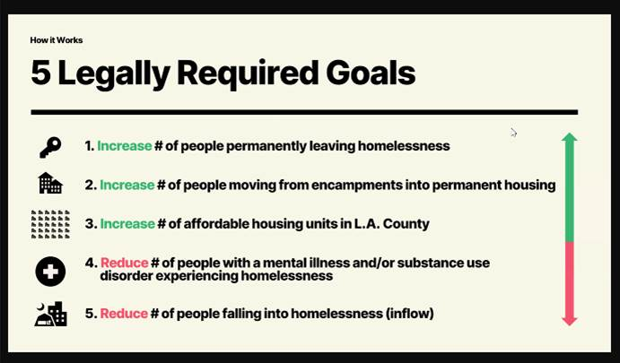
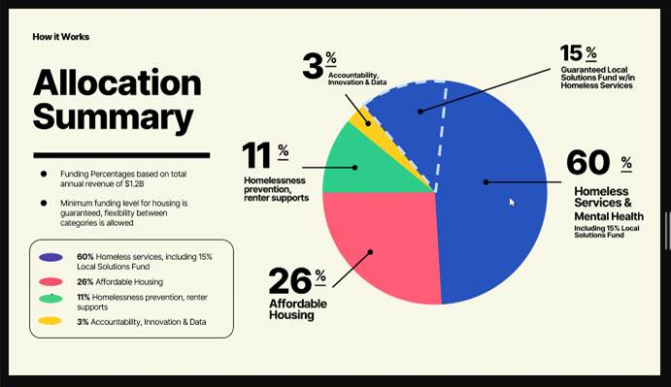
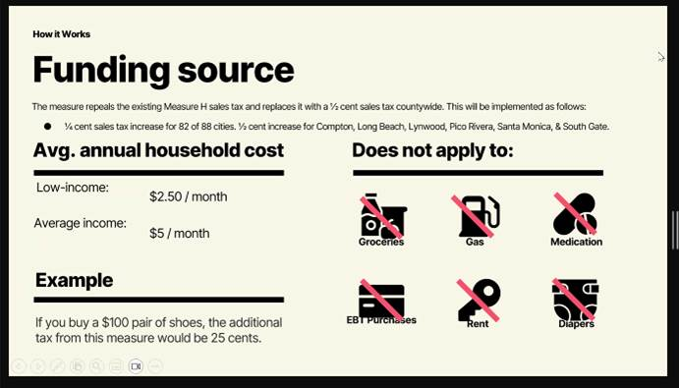

Asam: billions of dollars were mismanaged for Measure H. What is in place to prevent that with Measure A? Veronica: the legal requirements and reporting, auditing. Monitoring, measuring, and data. Built in accountability measures for agencies, cities, etc.
Carielle: COC conversations are also planning for accountability, whether for Measure A or other funds.
Presentation on Measure A from Ronson. This is purely an information session. No position from the Board.
- Tax is increasing to account for LACAHSA, accountability and data, etc.
- Measure A is a funding vehicle for LACAHSA, but not totally tied to Measure A (will still exist if the measure doesn’t pass)
- Housing creation, preservation, and ownership: 40% of the LACAHSA pie – really interested in NOAHs
- Highlighted the new CEO, Ryan Johnson (investment banking, been involved in work in NY, NJ, the Carolinas). Will bring in new thinking and perspectives
- A lot of money is coming from philanthropy currently. If Measure A passes, LACAHSA hits the ground running. Otherwise, LACAHSA needs to find more funding.
- Affordable Housing Trust Fund, doing studies in the South Bay to establish our own.

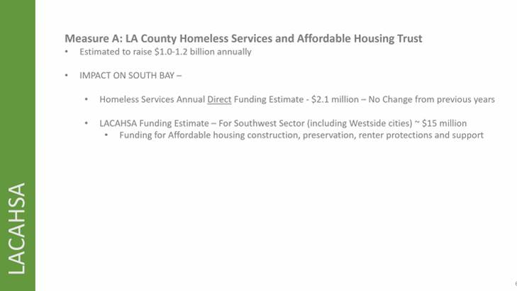

Good Neighbor Pledge – Ronson
- Executive Committee has taken up the pledge and being reviewed by other cities in the county. Barger and Mitchell have signed onto it. Effort on the county level to sign onto this
- Continue to invest in Homeless Services, shelter, and using anticamping enforcement as a framework to compel folks to accept services. The goal is to prioritize services before enforcement.
- Also taking this pledge to our cities, need it to be agendized. About halfway through, and will provide update when more cities have passed it on
Other Announcements
- Roberto: Announcing the Pathway Home project in Inglewood. So far it’s been a success and encouraging other jurisdictions to look into it with CEO-HI. Connects to motel master leases. Last count they had 15-20 folks housed in one day
  - Ronson highlighted the collaboration with the county to help solve the encampments
Erik Vargas – SPA 8 LAHSA
- Possibly changing homeless count days, considering changing SPA 8 date to Thursday
- Reasons: balance more equitably the resources across the three nights (first night is SPA 2 and 3 which are the two largest areas and have most deployment sites). Minimize make up census tracts, equitably distribute sites. SPA 4 and 6 will be conducted. Increase visibility of homelessness. Ensure resources are more equitably conducted in areas where the count is in the morning.
- Leaving contact information for feedback: Work Phone: 213-544-5559, email: evargas@lahsa.org
Marco Santana – CEO HI
- With HI, contract every year for the local solutions fund. Contract fully executed as August 2024, infuses the funding for the COG
- County has started its annual Measure H allocation recommendation process. Listening sessions the last few months, will have a draft budget soonish and more listening sessions at the end of this year. May change by end of the year per Measure Ad
- Thanked Cities for attending listening sessions
- Inglewood is the 20th operation, brought in over 1000 people off the streets
Laurie Jacobs on Homeless Count
- Shouldn’t be a problem changing the date, but saw Viet said it will be a problem in Torrance
- Need someone to help coordinate San Pedro as deployment site coordinator
- Zulma : social services commission leads the homeless count, gather volunteers. Thursdays are the Social Services Commissions, already on the calendar and there’s a long process to cancel them.

Adjournment to December 4, 2024

Links:

